CA-6: As a clinic staff, I want to record a patient's consultation, so that I can properly document the patient's diagnosis, treatment plan, and prescribed medicines for accurate patient records and inventory management.

Rationale
This documentation focuses on the design and development of the consultation recording feature of the clinic desktop application for clinic staff. It aims to provide a reliable way to document a patient’s diagnosis, treatment plan, and prescribed medicines in the patient’s medical record. When a prescription is saved, the system checks the available medicine stock and deducts the prescribed quantity, so the clinic’s inventory stays accurate. To be user-friendly, the system gives clear feedback when the stock is insufficient and prevents the prescription from being processed.
Scope of Work

Business Value

System Architecture
The desktop application (e.g., built using Java SE) will utilize a standard tiered architecture to separate the user interface from business logic and data access.
- Presentation Layer (UI): The desktop interface handling user inputs (username and password). It performs preliminary client-side validation to ensure fields are not empty before invoking backend services.
- Business Logic Layer (Authentication Service): Receives the login request. It is responsible for fetching user details from the database, hashing the provided password, and comparing it against the stored hash.
- Data Access Layer (DAO/Repository): Manages the connection and queries to the application's database.
- Database: Stores the registered user accounts, roles, and securely hashed passwords.

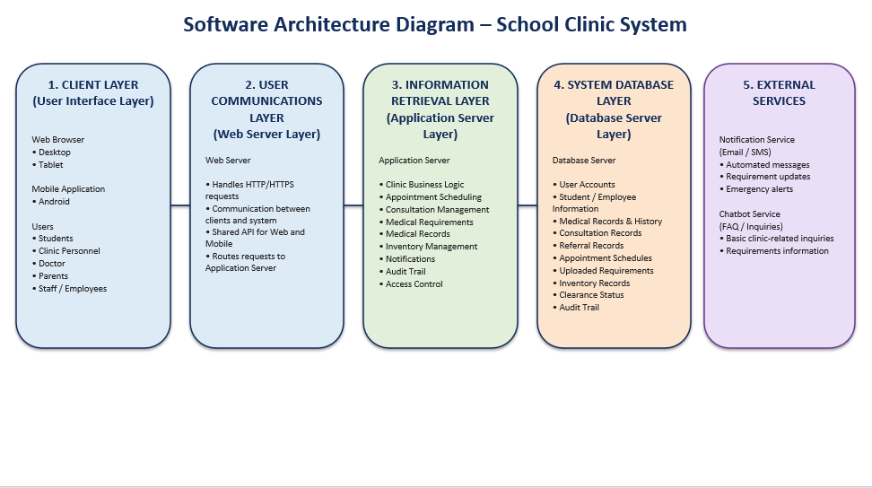

Data Models

Use Case Diagram

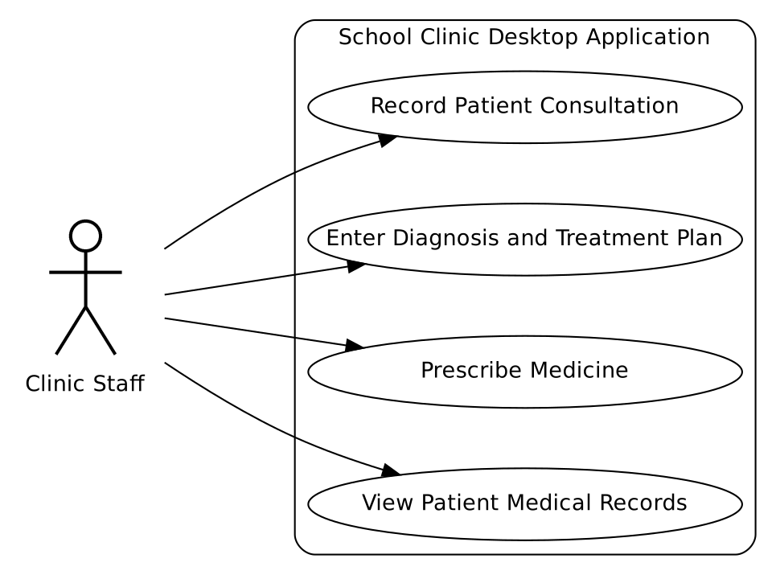

Activity Diagram
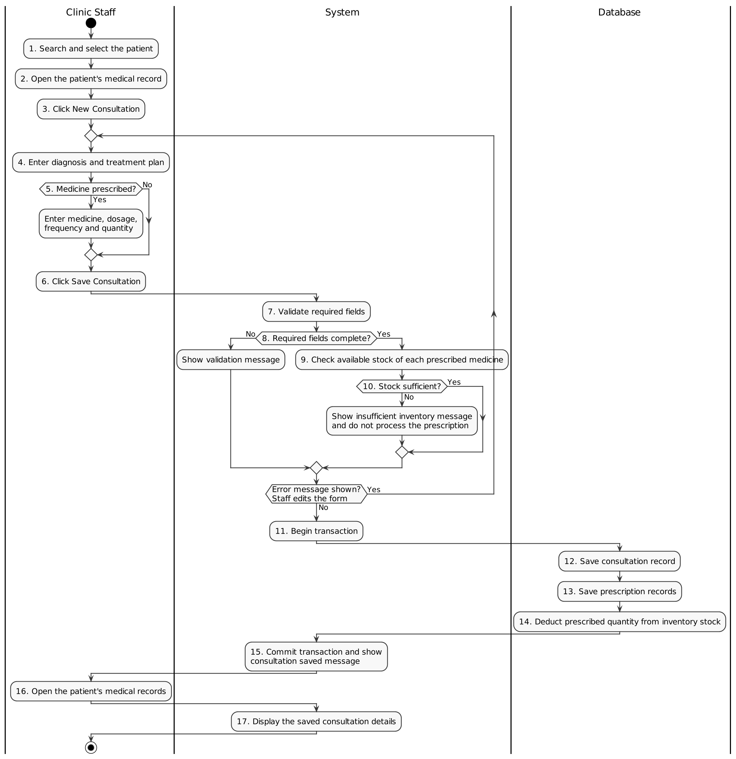

Sequence Diagram(Save consultation)

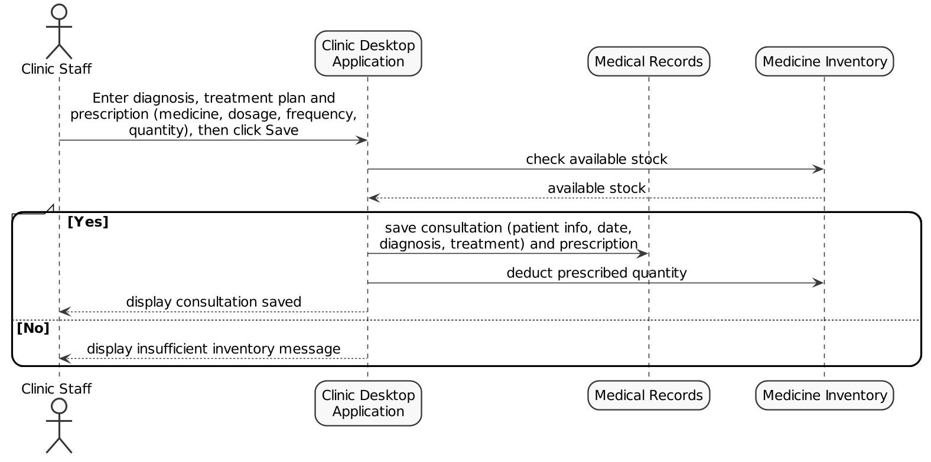

Sequence Diagram(View consulation)
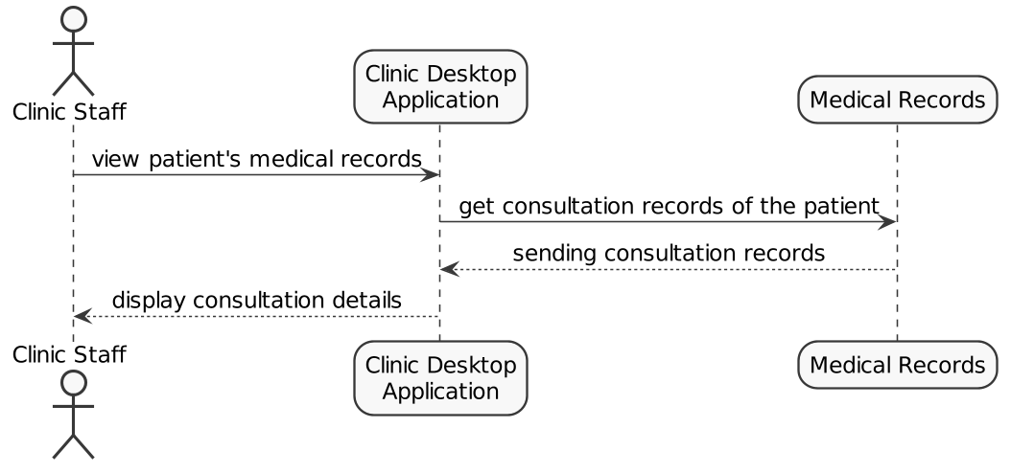

Entity Relationship Diagram

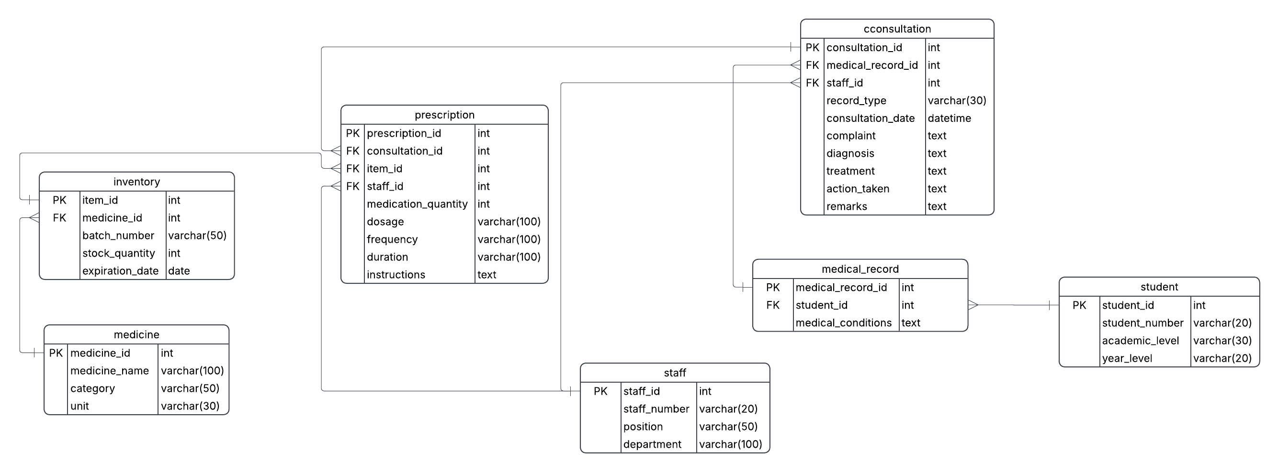

Database Design

Table 1, Student table
Field name | Data type | Description
student_id | INT | Auto-generated unique identifier for the student.
student_number | String | Unique student identification number.
academic_level | String | Academic level of the student (ex, Elementary, Junior High, Senior High, College).
year_level | String | Year or grade level of the student.

Table 2, Staff table
Field name | Data type | Description
staff_id | INT | Auto-generated unique identifier for the staff record.
staff_number | String | Unique staff identification number.
position | String | Staff member's job position or title.
department | String | Department where the staff member is assigned.

Table 3, Consultation table
Field Name | Data Type | Description
consultation_id | INT | Auto-generated unique identifier for the consultation.
medical_record_id | INT | References the medical record associated with the consultation.
staff_id | INT | References the staff member who handled the consultation.
record_type | String | Type of consultation record (e.g., Check-up, Emergency).
consultation_date | DATETIME | Date and time the consultation took place.
complaint | String | Patient's reported complaint or symptoms.
diagnosis | String | Diagnosis given during the consultation.
treatment | String | Treatment provided during the consultation.
action_taken | String | Action or actions taken by the staff member.
remarks | String | Additional notes or remarks about the consultation.

Table 4, Medical Record table
Field name | Data type | Description
medical_record_id | INT | Auto-generated unique identifier for the medical record.
student_id | INT | References the student who owns this medical record.
medical_conditions | String | Description of the student's known medical conditions.

Table 5, Medicine table
Field name | Data type | Description
medicine_id | INT | Auto-generated unique identifier for the medicine.
medicine_name | String | Name of the medicine.
category | String | Category or classification of the medicine.
unit | String | Unit of measurement for the medicine (ex, tablet, ml, bottle).

Table 6, Prescription table
Field Name | Data Type | Description
prescription_id | INT | Auto-generated unique identifier for the prescription.
consultation_id | INT | References the consultation during which the prescription was given.
item_id | INT | References the inventory item or batch prescribed.
staff_id | INT | References the staff member who issued the prescription.
medication_quantity | INT | Quantity of medication prescribed.
dosage | String | Prescribed dosage amount.
frequency | String | How often the medication should be taken.
duration | String | Length of time the medication should be taken.
instructions | String | Additional instructions for taking the medication.

Table 7, Inventory table
Field name | Data type | Description
item_id | INT | Auto-generated unique identifier for the inventory item.
medicine_id | INT | References the medicine associated with this inventory batch.
batch_number | String | Batch number of the medicine stock.
stock_quantity | INT | Current quantity of the medicine in stock.
expiration_date | DATE | Expiration date of the medicine batch.

Component Specification
Component | Description
Consultation | Model class containing consultation_id, medical_record_id, consultation_date, diagnosis, and treatment.
Prescription | Model class containing prescription_id, consultation_id, item_id, medication_quantity, dosage, and frequency.
ConsultationDao | DAO interface that specifies an insert method with a Consultation parameter and a findByMedicalRecordId method that accepts a medical record ID.
ConsultationDaoImpl | Implementation of the ConsultationDao interface that handles database operations for consultation records.
PrescriptionDao | DAO interface that specifies an insert method with a Prescription parameter and a findByConsultationId method that accepts a consultation ID.
PrescriptionDaoImpl | Implementation of the PrescriptionDao interface that handles database operations for prescription records.
ConsultationFacade | Service interface that specifies the saveConsultation method, which accepts a consultation and a list of prescriptions, and the getConsultationsByMedicalRecord method.

